How to Create an Online

Advance Care Plan

Welcome!

Thank you for taking this important step to make sure your wishes are known in the event of a health care crisis. Now more than ever, it is important to plan ahead before an emergency happens.
This process of planning ahead is called advance care planning. Advance care planning is identifying and writing down what type of health care you would want and naming a person (called a health care agent) who can speak for you if you are unable to speak for yourself. Without an advance care plan or a health care agent loved ones and doctors may make decisions that do not reflect your wishes.
Voice Your Choice is proud to be able to offer an online tool that allows your care plan to be easily accessed in an emergency and mobile across different types of health care settings and providers. We are committed to supporting you in creating your online advance care plan. This detailed step-by-step manual will guide you through the process. If you would like to explore additional tools for the online platform, please see the “Additional Resources for the Voice Your Choice Online Platform.” We hope you find this guide and all the Voice Your Choice materials helpful. Please feel free to share these resources with your friends, family, and colleagues.
If you need additional support, please visit the Voice Your Choice website. There are additional resources that will provide key information about advance care planning.

Table of Contents

Creating Your Account
The Voice Your Choice Website Portal………………………………………..……………..………..3
Register Your Account………………………………………………………………………………………….5

Completing Your Advance Care Plan
My Health Care Agent……………………………………………………………………………………….10
My Advance Care Goals…………………………………………………………………………………....14
My Preferences in Certain Circumstances …………………………………………………………17
My End-of-Life Preferences ………………………………………………………………………………23
My Thoughts……………………………………………………………………………………………………..28

Reviewing and Signing Your Advance Care Plan
Review Your Advance Care Plan…………………………………………………………………………31
Sign Your Advance Care Plan…………………………………………………………………………..…33

Creating Your Account

Step 1: Go to the Voice Your Choice Website Portal
The first step to creating your online advance care plan is to go to your web browser (e.g. – Google, Bing, Explorer) and type in www.VoiceYourChoice.org. This will bring you to the Voice Your Choice website (see picture below).

When arriving at Voice Your Choice’s homepage, you will be asked to fill out a brief questionnaire to aid us in understanding how you heard about the program and evaluate our outreach efforts. We appreciate your participation!
- Please fill out your first and last name
- Enter your email address
- Select from the dropdown menu how you heard about us
- Click the green Submit button

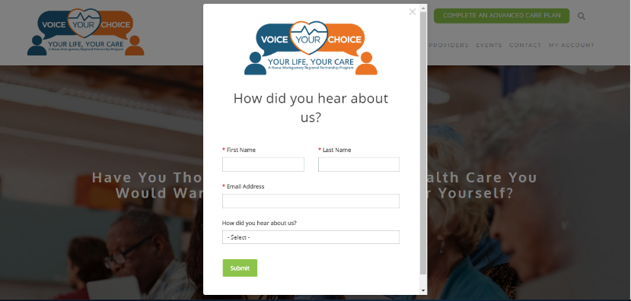
3
1
2
4

Step 2: REGISTER YOUR ACCOUNT

1. Click on the COMPLETE AN ADVANCED CARE PLAN green button.
- Once you click, a new tab will open automatically taking you to the online advance care planning platform
1
- Then click on the New User button
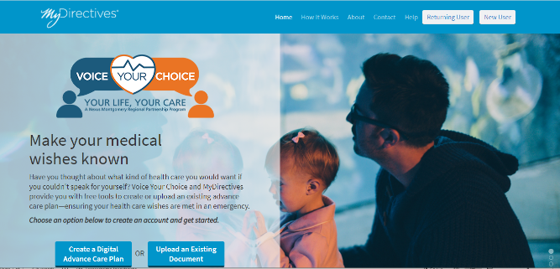
1

Create Your Voice Your Choice Online Account:

- Fill out your first and last name
- Choose a username
- Enter your personal email address (and NOT a work email address)
- Provide your phone number (optional)
- Click on the upside-down triangles in the calendar dropdown menu to enter your date of birth
- Alternately, you can use Facebook to sign up
- The Get Started video in the top right-hand corner provides additional information
- You can also click on the Need Help? Button under the video for assistance
- When you are finished click the SUBMIT button

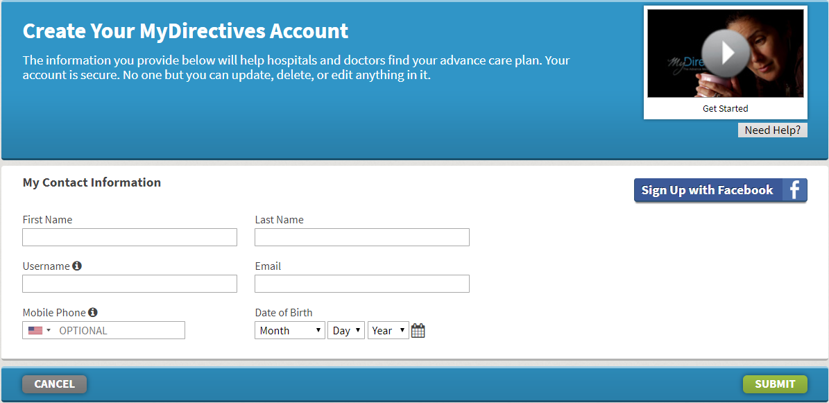
9
7
8
6
5
3
1
2
4
You will see a confirmation message that informs you an email has been sent to you.
- Open a new tab on your browser and go to your email
*Important: Do not X out the current tab or type in your email
1
When you open your email, you should see an email from info@mydirectives.com with the subject: “Confirm your email address on MyDirectives.”
If you did not receive an email:
- Wait for a minute and refresh your inbox
- Check your spam folder
- Return to the Voice Your Choice tab with the email confirmation message and click on the blue text I did not receive the confirmation email
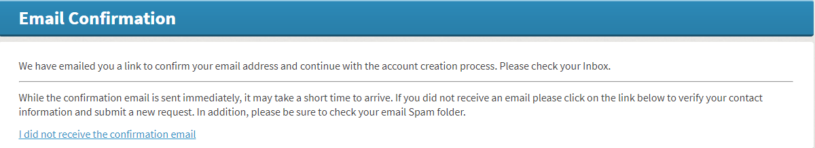
c

When you open the confirmation email, you will see the message below.
- Click the blue Continue button which will open a new tab
- If the blue Continue button does not redirect you to a new tab:
  - Copy the blue underlined URL text
  - Paste the text into a new tab and hit enter

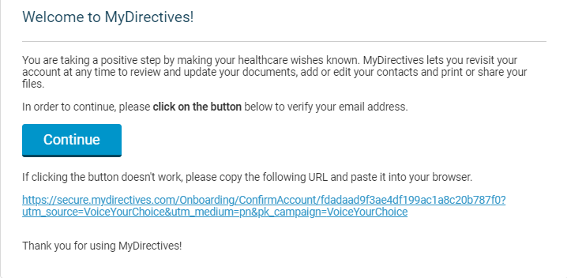
2a
1

2b

You will see the page below.
- Create a password that includes at least 1 capital letter, 1 lowercase letter, 1 number, 6 characters, and does not include spaces
- Enter the same password in the second text box to match the first
*Important: All the text lines in the grey box will have green check marks next to them once your password includes all the required entities

*Important
2
1

- Check the box to agree to the Terms and Conditions of Use
- If you would like to read the details, you can click the blue text
- Click Save and Continue
3
2
1
Completing Your Advance Care Plan

The My Decisions Tab

Section 1: MY HEALTH CARE AGENT
Navigate to My Health Care Agent
To navigate to the page labeled My Health Care Agent:
- Scroll to the top of the page and click on My Decisions
- A dropdown menu will appear. Please select My Health Care Agent
- For additional information, there is an available video labeled My Health Care Agent
- Need Help? is available for further text information
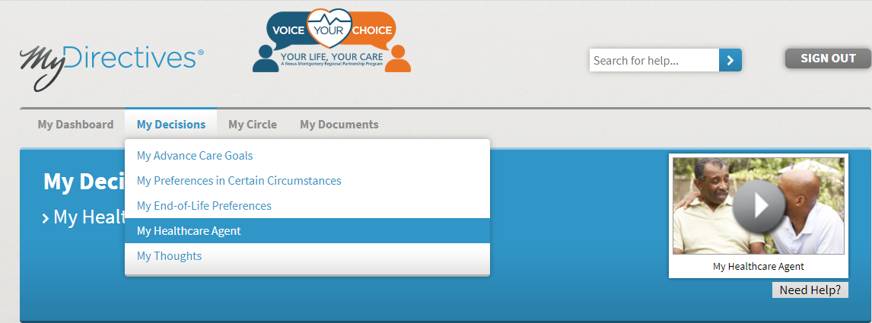
1
2
4
3

Resource: Discussion Guide
- Before answering these questions if you would like to discuss the topics
further with your health care agent, you can click on the blue underlined text to open the Discussion Guide
- You may click on any of the underlined blue text for more information

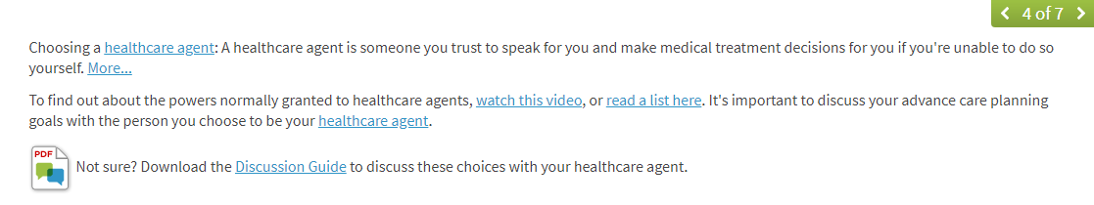
1
2

- If you do not wish to designate a health care agent at this time, you can check the corresponding space
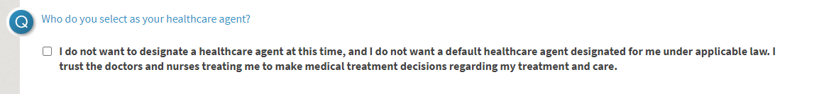
1
Step 1: Designate a Health Care Agent(s)
My Health Care Agent:
- Choose your health care agent’s title from the dropdown menu
- Fill in your health care agent’s first name
- Middle name is optional
- Fill in your health care agent’s last name
- If applicable, choose your health care agent’s suffix from the dropdown menu
- Choose your health care agent’s relationship to you from the dropdown menu

6
5
4
3
2
1

How to Contact:
- Fill in your health care agent’s email address
- Home phone number is optional
- Mobile phone number is optional
- Business phone number is optional
- Choose whether to add an address or not:
- If you would like to add your health care agent’s address, click Add Address and complete required fields
- Click SAVE

4
2
3
1
6
5a
It is optional to choose one or two alternates in case your original choice for health care agent is not able to serve. If you choose to add one or two alternates.
Adding Alternate Healthcare Agents (Optional):

- Click Add someone new
1

- Complete the form as you did for the original health care agent

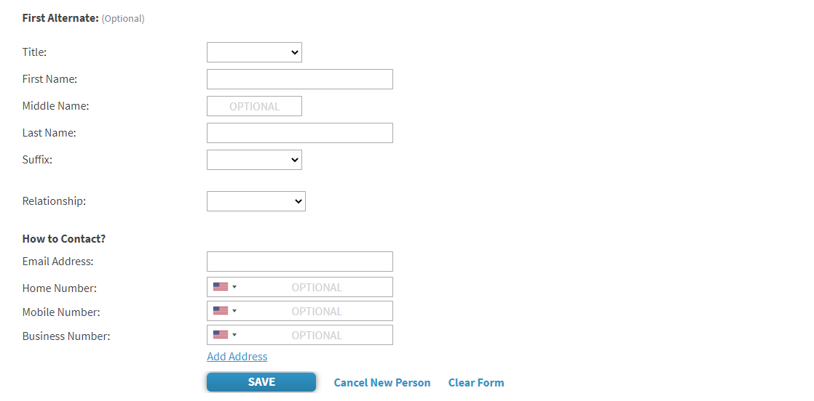
2
Step 2: Choose the Powers to Give Your Health Care Agent(s)
- Read the list of powers
- Please choose one of the answers by clicking on the corresponding space
2
1

- If you chose the second answer, to limit or expand my agent’s powers in the following ways, you must detail your health care agent’s powers in the text box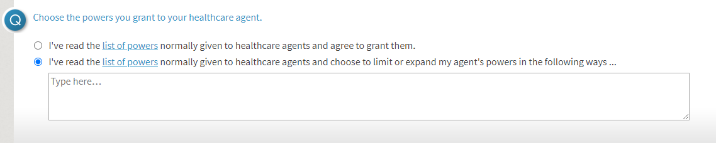
3

Step 3: Save and Continue
- Click Save and Continue to navigate to the next page, My Thoughts

1

Section 2: MY ADVANCE CARE GOALS
Go to My Advance Care Goals:
- Scroll to the top of the page and click on My Decisions
- A dropdown menu will appear. Please select My Advance Care Goals
- For additional information, there is an available video labeled My Decisions
- Need Help? is available for further text information
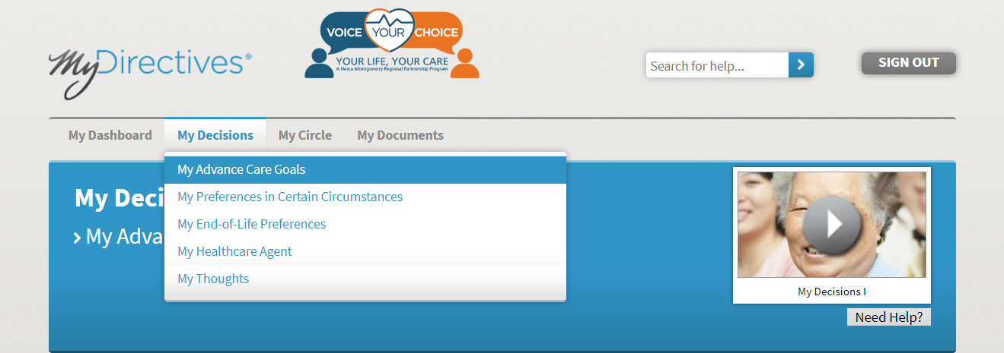
2
1
4
3

Question 1 - What is Important to You?
- Check all the boxes that apply to your values by clicking once on the corresponding box
- If you accidentally choose a value that you do not agree with, you can click the box a second time and the check mark will be removed
- You can click on the underlined blue text to see examples of others’ answers
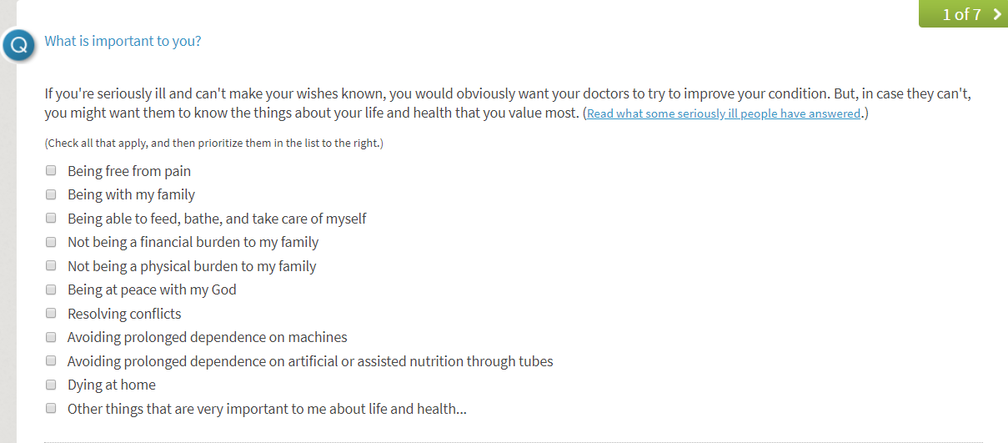
3
1

- Your values will automatically be listed in the order that you selected them under My Priorities
- To rearrange the prioritization of values:
  - You can use the blue arrows to move items up and down
  - You can also drag the text up or down the list by hovering your mouse over the value until the 4-direction arrow appears and drag the value to your desired position
- If you want to remove a choice simply clicking the X

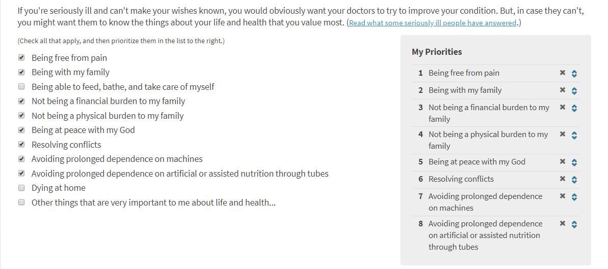
2b
2a
3
1

Question 2 - Religion, Faith, & Spirituality

- Choose Yes or No by clicking the corresponding space
1
- If you chose Yes, you must fill in a belief or observance in the text box before you are able to move onto the next question
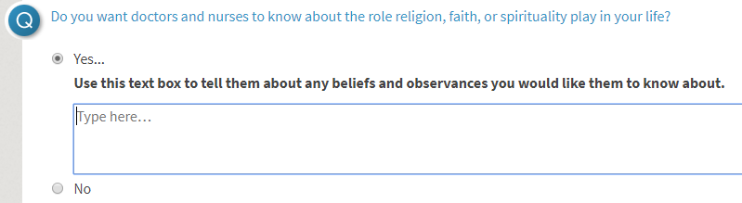
1

Question 3 - Supportive and Palliative Care Team
- Choose Yes or No by clicking the corresponding space
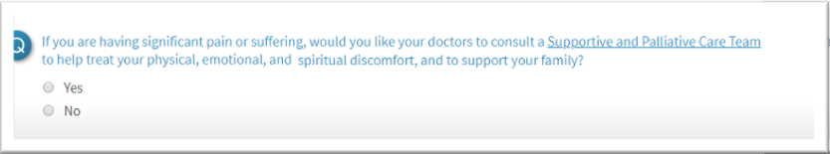
1

Save Your Selections!
- Click Save and Continue to navigate to the next page, My Preferences in Certain Circumstances
1
Section 3: MY PREFERENCES IN CERTAIN CIRCUMSTANCES
Go to My Preferences in Certain Circumstances:
- After clicking Save and Continue, you should be automatically brought to the My Preferences in Certain Circumstances page. If not, scroll to the top of the page and click on My Decisions
- A dropdown menu will appear. Please select My Preferences in Certain Circumstances
- For additional information, there is an available video labeled My Decisions II
- Need Help? is available for further text information
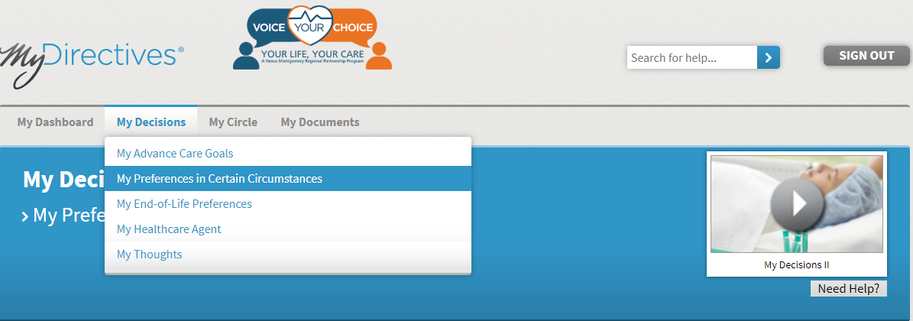
4
3
2
1

Resource: Discussion Guide
- Before answering these questions, if you would like to discuss the topics further with your doctor or family, you can scroll to the bottom of the page and click on the blue underlined text to open the Discussion Guide to use as conversation tool.
1

Question 1 - Terminal Illness
- Choose one of the three answers below by clicking the corresponding space
- You may click on any of the underlined blue text for more information
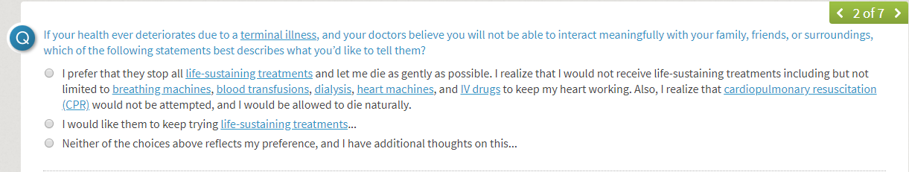
2
1

If you chose the first answer, to stop all life sustaining treatment and let me die as gently as possible, a pop-up window will appear, and you must choose a follow-up answer.
- Please choose one of the answers by clicking on the corresponding space
- You may click on any of the underlined blue text for more information
- Once you have selected, click SAVE

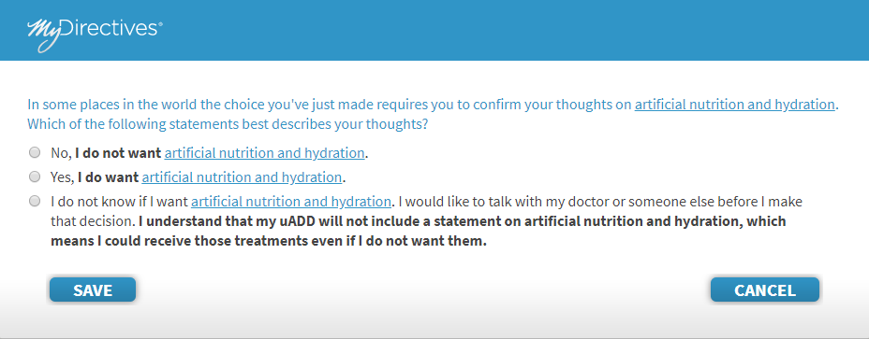
3
2
1
If you chose the second answer, to keep trying life sustaining treatments, more choices will become available and you must choose a follow-up answer
- Please choose one of the answers by clicking on the corresponding space
- If you choose the first answer, you must designate a period of time. Place a number in the first box and then from the dropdown menu choose either day(s), week(s), month(s), or year(s)
- You may click on any of the underlined blue text for more information

3
2
1

If you chose the third answer, neither of the choices above reflects my preference, a pop-up window will appear and you must choose a follow-up answer
- Please choose one of the answers by clicking on the corresponding space
- You may click on any of the underlined blue text for more information
- Once you have selected, click SAVE
3
2
1
Question 2: Brain Injury or Illness
- Choose one of the answers below by clicking the corresponding space
- You may click on any of the underlined blue text for more information
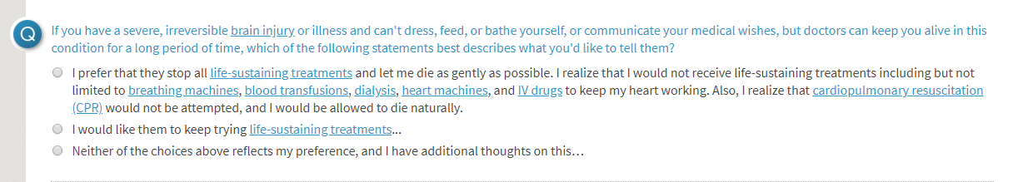
2
1
If you chose the first answer, I prefer they stop all life-sustaining treatment and let me die as gently as possible, a pop-up window will appear and you must choose a follow-up answer.
- Please choose one of the answers by clicking on the corresponding space
- You may click on any of the underlined blue text for more information
- Once you have selected, click SAVE

3
2
1

If you chose the second answer, I would like them to keep trying life-sustaining treatments, more choices will become available and you must choose a follow-up answer.
- Please choose one of the answers by clicking on the corresponding space
- If you choose the first answer, you must designate a period of time. Place a number in the first box and then from the dropdown menu choose either day(s), week(s), month(s), or year(s)
- You may click on any of the underlined blue text for more information

3
2
1

If you chose the third answer, neither of the choices above reflects my preference, a pop-up window will appear and you must choose a follow-up answer.
- Please choose one of the answers by clicking on the corresponding space
- You may click on any of the underlined blue text for more information
- Once you have selected, click SAVE

2
3
1

Question 3: Cardiopulmonary Resuscitation (CPR)

- Please choose one of the answers by clicking on the corresponding space
- You may click on any of the underlined blue text for more information

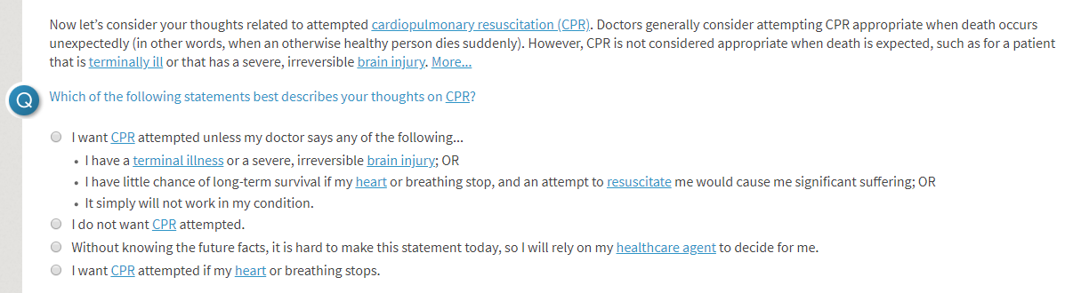
2
1

- If you would like to provide additional thoughts, click on I have additional thoughts on this... and a text box will be displayed, and you may share your thoughts in the text box
- You may click on the underlined blue text for more information

2
1
Save Your Selections!
1
- Click Save and Continue to navigate to the next page, My End-of-Life Preferences

Section 4: MY END-OF-LIFE PREFERENCES
Navigate to My End-of-Life Preferences
To navigate to My End-of-Life Preferences:
- Scroll to the top of the page and click on My Decisions
- A dropdown menu will appear - select My End-of-Life Preferences
- For additional information, there is an available video labeled My End-of-Life Preferences
- Need Help? is available for further text information
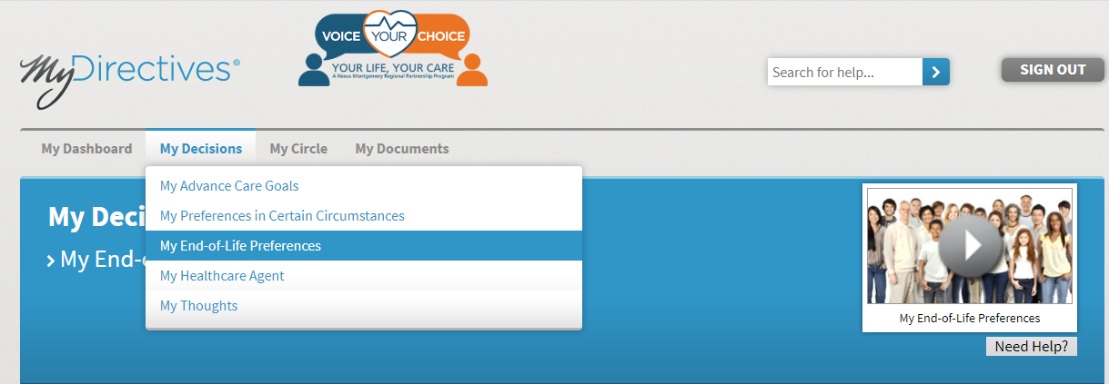
4
3
1
2
Question 1: Final Days Location
- Please choose only one of the answers by clicking on the corresponding space
- You may click on the underlined blue text for more information

2
1
- If you chose the first answer, At home, a secondary question will appear for follow-up:
*Important - this is an example - check this box ONLY if you agree with the statement

1
- If you chose the second answer, In the hospital, a secondary question will appear for follow-up:
*Important- this is an example, check this box ONLY if you agree with the statement

1
- If you would like to provide additional thoughts, type in the text box
- You may click on the underlined blue text for more information
2
1
Question 2: Portable Medical Order
- Choose Yes or No by clicking the corresponding space
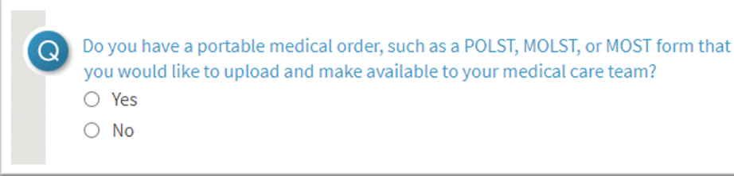
1
If you chose yes:
- Please choose a title for your document.
- Select which type of document you will upload from the dropdown menu.
- Fill in the date the document was created by typing directly into the text box or using the calendar
- To upload your document:
- Make sure your document is saved on your computer.
*Important - If you need help with saving documents on your computer please see the Guide to Additional Resources
- Click in the box where the grey text states Select a document and navigate to your saved document. Click on the document and choose Open.
- Choose SAVE
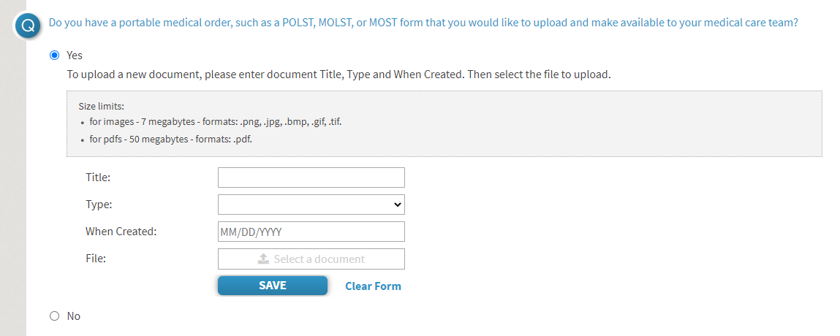
4c
3
2
4b
1

Question 3: Organ and Tissue Donation
- Please choose one of the answers by clicking on the corresponding space
- You may click on the underlined blue text for more information
2
1
If you chose the first answer, to donate my organs, a second question will appear:
- Please choose one of the options by clicking on the corresponding space
If you chose the second answer, to donate only the following, you must specify your answer in the text box provided
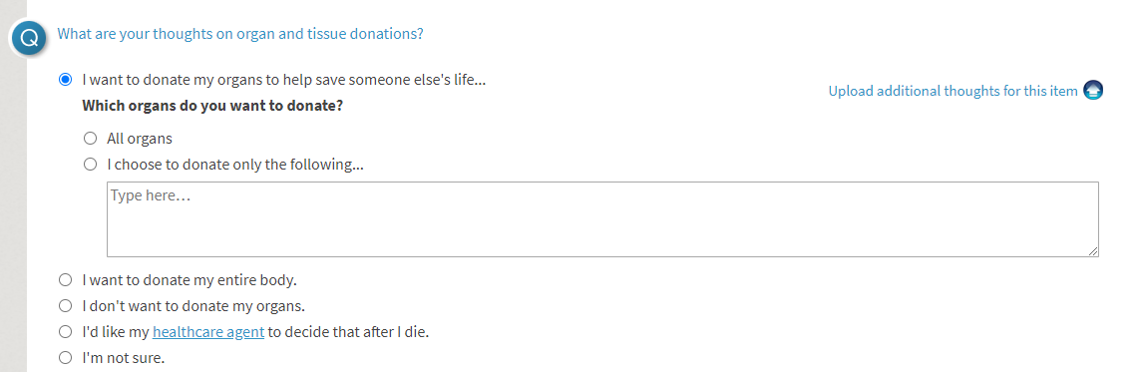
1
1a
- If you would like to provide additional thoughts, click on I have additional thoughts about this… and a text box will be displayed, and you can share your thoughts in the text box
- You may click on the underlined blue text for more information
2
1

Save Your Selections!
1
- Click Save and Continue to navigate to the next page, My Health care Agent.

Section 5: MY THOUGHTS
Step 1: Navigate to My Thoughts
To navigate to the page labeled My Thoughts:
- Scroll to the top of the page and click on My Decisions
- A dropdown menu will appear. Please select My Thoughts
- For additional information, there is an available video labeled My Thoughts
- Need Help? is available for further text information

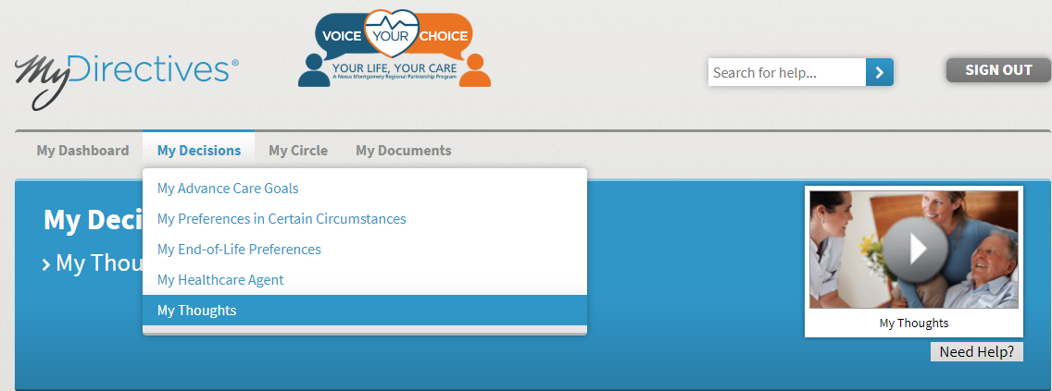
4
3
2
1

Step 2: Complete Questions

Question 1: My Likes / Joys
- In the text box, you may share your likes / joys.
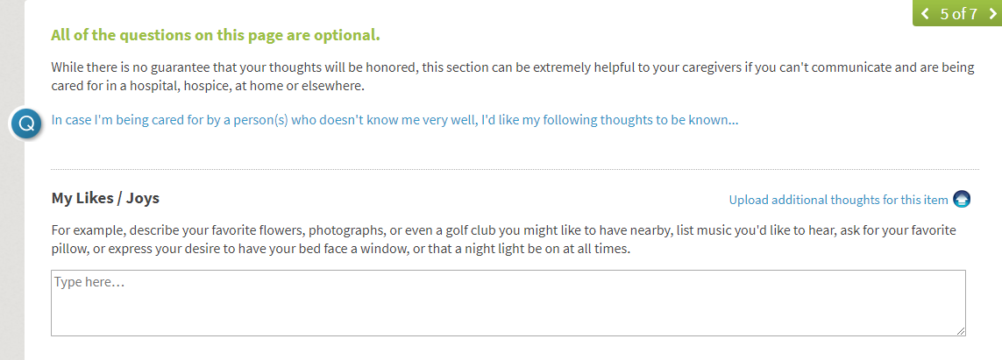
2a
1
Follow this same process for:
- My Dislikes/Fears
- How to Care for Me
- My Religion
- My Unfinished Business
- If I Were to Pass Away
- Laughter
- Message to People Who Matter to Me

Step 3: Save and Continue
- Click Save and Continue to navigate to the next page, My Contacts
1

Reviewing and Signing Your Advance Care Plan
Step 1: Navigate to Sign My Documents
To navigate to the page labeled Sign My Documents:
- Scroll to My Dashboard
- Choose Sign Now
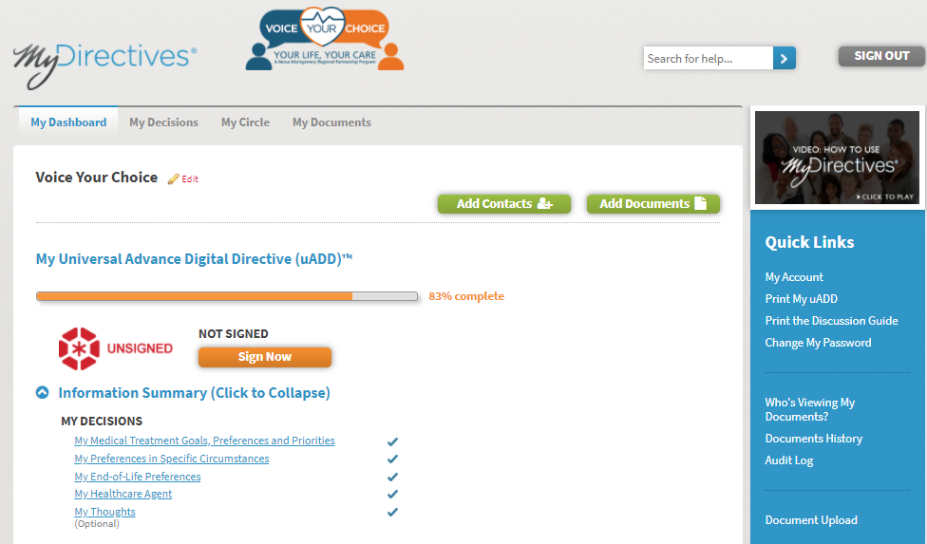
2
1
OR
- Scroll to the top of the page and click on My Documents
- A dropdown menu will appear. Please select Sign My Documents
- For additional information, there is an available video labeled My Documents
- Need Help? is available for further text information.
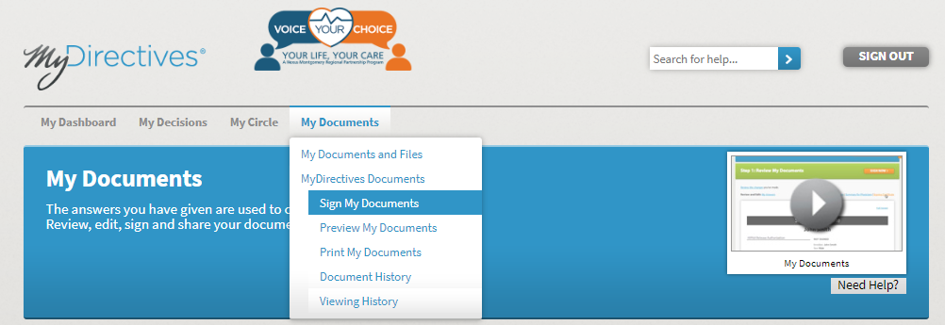
5
6
4
3
- Select START - You will be directed to Review My Documents
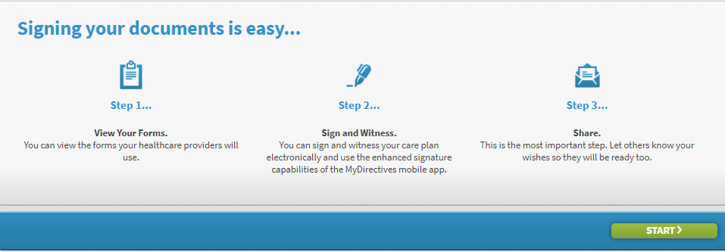
1
Section 1: REVIEW DOCUMENTS
Step 1: Navigate to Preview My Documents
To navigate to the page labeled Preview My Documents:
- Scroll to the top of the page and click on My Documents
- A dropdown menu will appear. Please select Preview My Documents
- For additional information, there is an available video labeled My Documents
- Need Help? is available for further text information

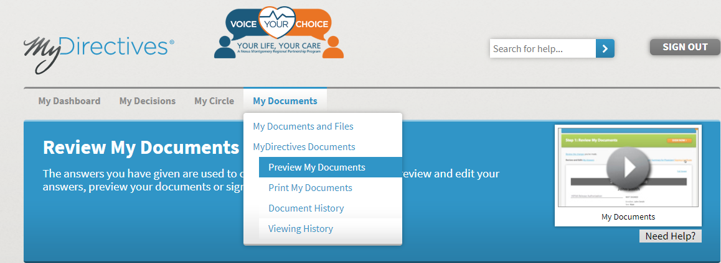
1
2
3
4
Step 2: Review My Advance Care Plan (uADD)
- Review your advance care plan (Universal Advance Digital Directive) by scrolling through the document
- While reviewing the document, if you would like to make edits you may click the Edit button
- You may Print the document or view in Full Screen
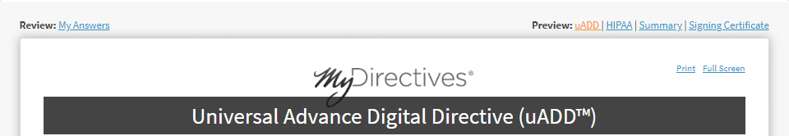
3
1
2a
- You can choose to SIGN NOW
a. If you choose to sign, click Sign Now at the bottom of the page
OR
Scroll to the top of the page to review your other documents

4
Section 2: SIGN DOCUMENTS
Step 1: Navigate to Signing Page
To navigate to the signing page:
- Scroll to the top of the page and click on My Documents
- A dropdown menu will appear. Please select Preview My Documents
- Choose the button SIGN NOW
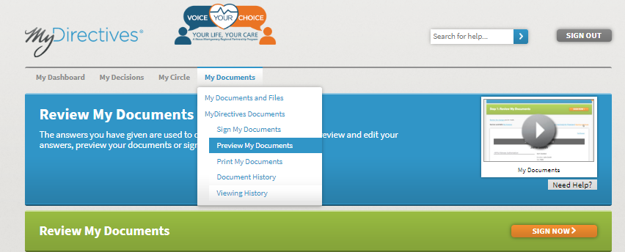
3
2
1
Step 2: Signing Your Advance Care Plan
You will be instructed to sign in again:
- Enter your Username
- Enter your Password
- Click SIGN IN AND CONTINUE
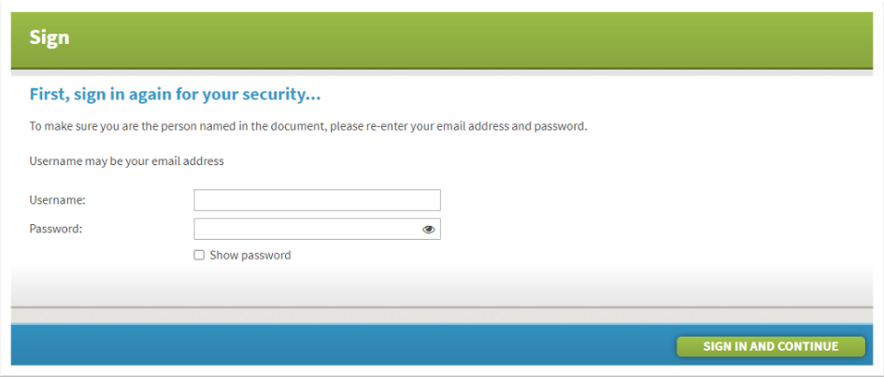
2
1
3
- Type your name as you would like it to appear on the signature page of your documents
- Click SAVE AND CONTINUE
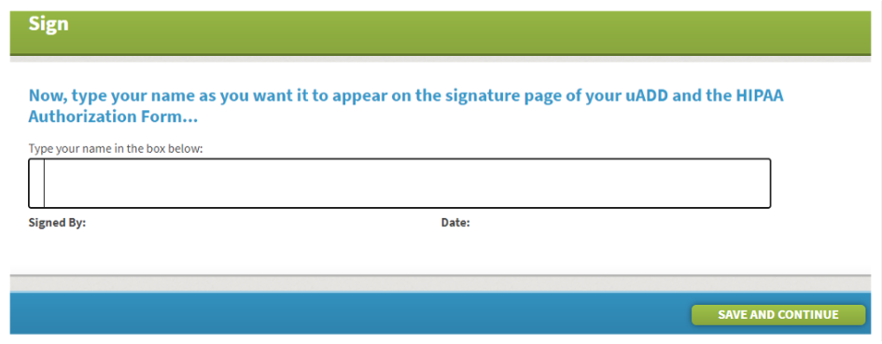
2
1
- The selected health care agents are checked to be contacted via email as default. If you would like for one or more not to be contacted, you can click the check box and the check will be removed and they will not be contacted.
- You may enter a personal message to be sent with the contact to your selected health care agent(s)
- You may select to have a copy of the email sent to your personal email
- Click NEXT

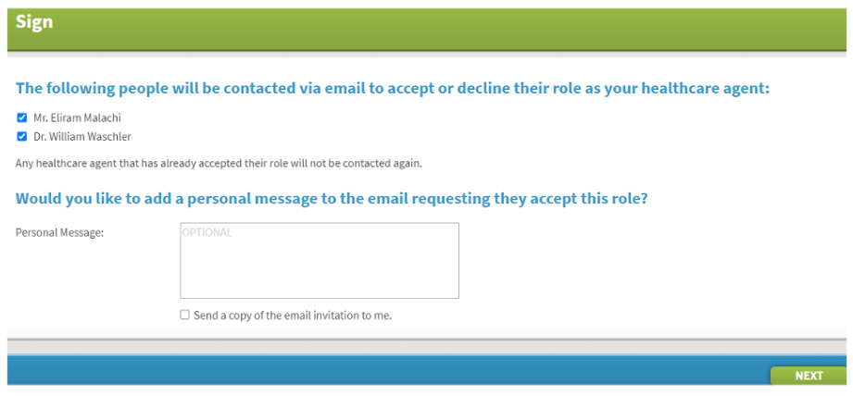
4
1
3
2
Mrs. Anne Smith

Mr. John Smith

*Important: You do not need a witness or a notary when you create your online advance care plan!

Step 3: Notification of Health care Agent
- Choose whether you would like to or would not like to notify your health care agent. We strongly suggest that you notify your health care agent.
- If you choose not to notify, click NO, I DO NOT WANT TO NOTIFY
- If you choose to notify, click OK, SEND THE NOTICE TO MY HEALTH CARE AGENT
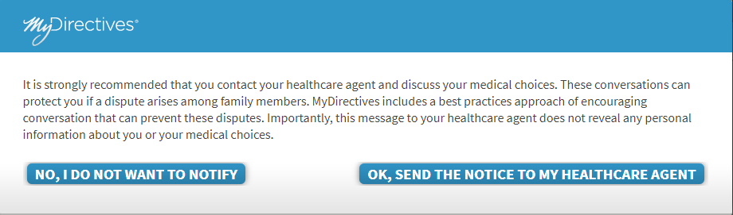
1a
1b

Step 4: Confirmation of Signature
The message: Congratulations! Your advance care plan has been signed! will appear to inform you that you have completed the signature phase. At the same time, you will receive an email confirming that you have completed the signature for your uADD (advance care plan).
No action is required.

*Important - to make sure your account is secure, you can use your social security number and your phone number. If you are uncomfortable with sharing this information you can put in “fake” phone number (e.g.: 123-456-7890) and then opt-out

- Fill in your social security number
- Fill in your mobile phone number
- Choose VERIFY IDENTITY

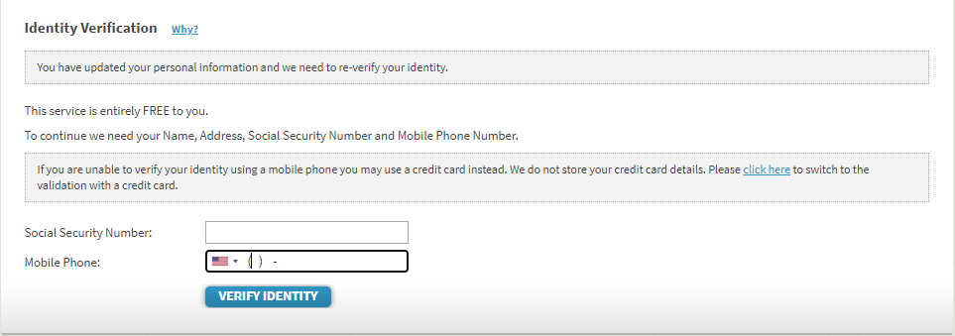
3
2
1

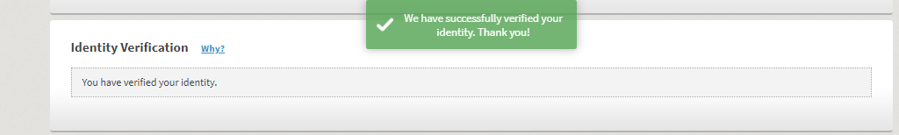

- If your identity is not verified or you would not like to share that information, you may choose to opt-out of identity verification

4

Congratulations!

You have completed your online advance care plan. Now your values and preferences will be known if you are unable to speak for yourself and your plan will be more accessible in an emergency and mobile across all sites of care. Be sure to let your doctor, health care agent and those who matter most to you, know about the creation of your online plan. You should review your plan periodically. You can set up a reminder on the online platform at a time interval that is best for you. If you would like to upload any documents to your account, see “How to Upload Advance Care Planning Documents.” There are more tools in the “Additional Resources for Online Advance Care Planning.”

